Movement Formations

3-24. This section discusses movement formations of Infantry fire teams, squads, and platoons. The platoon leader uses formations for several purposes: to relate one squad to another on the ground; to position firepower to support the direct-fire plan; to establish responsibilities for sector security among squads; or to aid in the execution of battle drills. Just as they do with movement techniques, platoon leaders plan formations based on where they expect enemy contact, and on the company commander’s plans to react to contact. The platoon leader evaluates the situation and decides which formation best suits the mission and situation.
3-25. Every squad and Soldier has a standard position. Soldiers can see their team leaders. Fire team leaders can see their squad leaders. Leaders control their units using hand-and-arm signals.
3-26. Formations also provide 360-degree security and allow units to give the weight of their firepower to the flanks or front in anticipation of enemy contact.
3-27. Formations do not demand parade ground precision. Platoons and squads must retain the flexibility needed to vary their formations to the situation. The use of formations allows Soldiers to execute battle drills more quickly and gives them the assurance that their leaders and buddy team members are in the expected positions and performing the right tasks.
3-28. Sometimes platoon and company formations differ due to METT-TC factors. For example, the platoons could move in wedge formations within a company vee. It is not necessary for the platoon formation to be the same as the company formation unless directed by the company commander. However, the platoon leader must coordinate his formation with other elements moving in the main body team’s formation. Figure 3-2 illustrates platoon symbols.

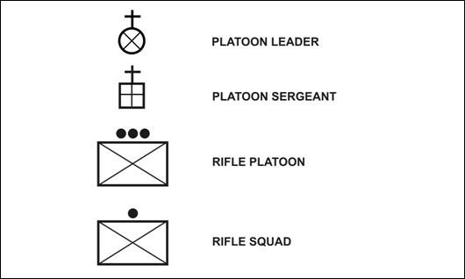
Figure 3-2. Legend of platoon symbols.

NOTE: The formations shown in the illustrations in this chapter are examples only. They generally are depicted without METT-TC considerations, which are always the most crucial element in the selection and execution of a formation. Leaders must be prepared to adapt their choice of formation to the specific situation.
Primary Formations
3-29. Combat formations are composed of two variables: lateral frontage, represented by the line formation; and depth, represented by the column formation. The advantages attributed to any one of these variables are disadvantages to the other. Leaders combine the elements of lateral frontage and depth to determine the best formation for their situation. In addition to the line and column/file, the other five types of formations—box; vee; wedge; diamond; and echelon—combine these elements into varying degrees. Each does so with different degrees of emphasis that result in unique advantages and disadvantages (Table 3-1).
3-30. The seven formations can be grouped into two categories: formations with one lead element, and formations with more than one lead element. The formations with more than one lead element, as a general rule, are better for achieving fire superiority to the front, but are more difficult to control. Conversely, the formations with only one lead element are easier to control but are not as useful for achieving fire superiority to the front.
3-31. Leaders attempt to maintain flexibility in their formations. Doing so enables them to react when unexpected enemy actions occur. The line, echelon, and column formations are the least flexible of the seven formations. The line mass to the front has vulnerable flanks. The echelon is optimized for a flank threat—something that units want to avoid. The column has difficulty reinforcing an element in contact. Leaders using these formations should consider ways to reduce the risks associated with their general lack of flexibility.

Table 3-1. Primary formations.
Name/Formation/  Signal (if applicable) | Characteristics | Advantages | Disadvantages
Line Formation  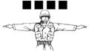 | – All elements arranged in a row  – Majority of observation and direct fires oriented forward; minimal to the flanks  – Each subordinate unit on the line must clear its own path forward  – One subordinate designated as the base on which the other subordinates cue their movement | Ability to:  – Generate fire superiority to the front  – Clear a large area  – Disperse  – Transition to bounding overwatch, base of fire, or assault | – Control difficulty increases during limited visibility and in restrictive or close terrain  – Difficult to designate a maneuver element  – Vulnerable assailable flanks  – Potentially slow  – Large signature
Column/File Formation  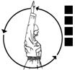 | – One lead element  – Majority of observation and direct fires oriented to the flanks; minimal to the front  – One route means unit only influenced by obstacles on that one route | – Easiest formation to control (as long as leader can communicate with lead element)  – Ability to generate a maneuver element  – Secure flanks  – Speed | – Reduced ability to achieve fire superiority to the front  – Clears a limited area and concentrates the unit  – Transitions poorly to bounding overwatch, base of fire, and assault  – Column’s depth makes it a good target for close air attacks and a machine gun beaten zone
Vee Formation  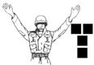 | – Two lead elements  – Trail elements move between the two lead elements  – Used when contact to the front is expected  – “Reverse wedge”  – Unit required to two lanes/routes forward | Ability to:  – Generate fire superiority to the front  – Generate a maneuver element  – Secure flanks  – Clear a large area  – Disperse  – Transition to bounding overwatch, base of fire, or assault | – Control difficulty increases during limited visibility and in restrictive or close terrain  – Potentially slow
Box Formation   | – Two lead elements  – Trail elements follow lead elements  – All-around security | See vee formation advantages | See vee formation disadvantages
Wedge Formation  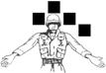 | – One lead element  – Trail elements paired off abreast of each other on the flanks  – Used when the situation is uncertain | Ability to:  – Control, even during limited visibility, in restrictive terrain, or in close terrain  – Transition trail elements to base of fire or assault  – Secure the front and flanks  – Transition the line and column | – Trail elements are required to clear their own path forward  – Frequent need to transition to column in restrictive, close terrain
Diamond Formation   | – Similar to the wedge formation  – Fourth element follows the lead element | See wedge formation advantages | See wedge formation disadvantages
Echelon Formation (Right)  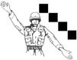 | – Elements deployed diagonally left or right  – Observation and fire to both the front and one flank  – Each subordinate unit on the line clears its own path forward | – Ability to assign sectors that encompass both the front and flank | – Difficult to maintain proper relationship between subordinates  – Vulnerable to the opposite flanks
FIRE TEAM FORMATIONS
3-32. The term fire team formation refers to the Soldiers’ relative positions within the fire team. Fire team formations include the fire team wedge and the fire team file (Table 3-2). Both formations have advantages and disadvantages. Regardless of which formation the team employs, each Soldier must know his location in the formation relative to the other members of the fire team and the team leader. Each Soldier covers a set sector of responsibility for observation and direct fire as the team is moving. To provide the unit with all-round protection, these sectors must interlock. Team leaders must be constantly aware of their team’s sectors and correct them as required.
Table 3-2. Comparison of fire team formations.
Movement Formation | When Most Often Used | CHARACTERISTICS
 |  | Control | Flexibility | Fire Capabilities and Restrictions | Security
Fire team wedge | Basic fire team formation | Easy | Good | Allows immediate fires in all directions | All-round
Fire team file | Close terrain, dense vegetation, limited visibility conditions | Easiest | Less flexible than wedge | Allows immediate fires to the flanks, masks most fires to the rear | Least
3-33. The team leader adjusts the team’s formation as necessary while the team is moving. The distance between men will be determined by the mission, the nature of the threat, the closeness of the terrain, and by the visibility. As a general rule, the unit should be dispersed up to the limit of control. This allows for a wide area to be covered, makes the team’s movement difficult to detect, and makes them less vulnerable to enemy ground and air attack. Fire teams rarely act independently. However, in the event that they do, when halted, they use a perimeter defense to ensure all-around security.
Fire Team Wedge
3-34. The wedge (Figure 3-3) is the basic formation for the fire team. The interval between Soldiers in the wedge formation is normally 10 meters. The wedge expands and contracts depending on the terrain. Fire teams modify the wedge when rough terrain, poor visibility, or other factors make control of the wedge difficult. The normal interval is reduced so all team members can still see their team leader and all team leaders can still see their squad leader. The sides of the wedge can contract to the point where the wedge resembles a single file. Soldiers expand or resume their original positions when moving in less rugged terrain where control is easier.
3-35. In this formation the fire team leader is in the lead position with his men echeloned to the right and left behind him. The positions for all but the leader may vary. This simple formation permits the fire team leader to lead by example. The leader’s standing order to his Soldiers is: “Follow me and do as I do.” When he moves to the right, his Soldiers should also move to the right. When he fires, his Soldiers also fire. When using the lead-by-example technique, it is essential for all Soldiers to maintain visual contact with the leader.
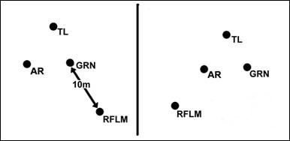
Figure 3-3. Fire team wedge.
Fire team File
3-36. Team leaders use the file when employing the wedge is impractical. This formation is most often used in severely restrictive terrain, like inside a building; dense vegetation; limited visibility; and so forth. The distance between Soldiers in the column changes due to constraints of the situation, particularly when in urban operations (Figure 3-4).

Figure 3-4. Fire team file.
SQUAD FORMATIONS
3-37. The term squad formation refers to the relative locations of the fire teams. Squad formations include the squad column, the squad line, and the squad file. Table 3-3 compares squad formations.
Table 3-3. Comparison of squad formations.
Movement Formation | When Most Often Used | CHARACTERISTICS
 |  | Control | Flexibility | Fire Capabilities and Restrictions | Security
Squad column | The main squad formation | Good | Aids maneuver, good dispersion laterally and in depth | Allows large volume of fire to the flanks but only limited volume to the front | All-around
Squad line | For maximum firepower to the front | Not as good as squad column | Limited maneuver capability (both fire teams committed) | Allows maximum immediate fire to the front | Good to the front, little to the flank and rear
Squad file | Close terrain, dense vegetation, limited visibility conditions | Easiest | Most difficult formation to maneuver from | Allows immediate fire to the flanks, masks most fire to the front and rear | Least
3-38. The squad leader adjusts the squad’s formation as necessary while moving, primarily through the three movement techniques (see Section III). The squad leader exercises command and control primarily through the two team leaders and moves in the formation where he can best achieve this. The squad leader is responsible for 360-degree security, for ensuring the team’s sectors of fire are mutually supporting, and for being able to rapidly transition the squad upon contact.
3-39. The squad leader designates one of the fire teams as the base fire team. The squad leader controls the squad’s speed and direction of movement through the base fire team while the other team and any attachments cue their movement off of the base fire team. This concept applies when not in contact and when in contact with the enemy.
3-40. Weapons from the weapons squad (a machine gun or a Javelin) may be attached to the squad for the movement or throughout the operation. These high value assets need to be positioned so they are protected and can be quickly brought into the engagement when required. Ideally, these weapons should be positioned so they are between the two fire teams.
Squad Column
3-41. The squad column is the squad’s main formation for movement unless preparing for an assault (Figure 3-5). It provides good dispersion both laterally and in depth without sacrificing control. It also facilitates maneuver. The lead fire team is the base fire team. Squads can move in either a column wedge or a modified column wedge. Rough terrain, poor visibility, and other factors can require the squad to modify the wedge into a file for control purposes. As the terrain becomes less rugged and control becomes easier, the Soldiers assume their original positions.
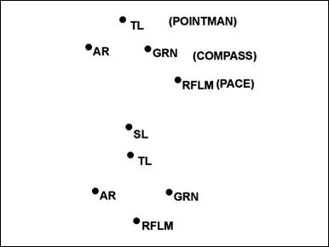
Figure 3-5. Squad column, fire teams in wedge.
Squad Line
3-42. The squad line provides maximum firepower to the front and is used to assault or as a pre-assault formation (Figure 3-6). To execute the squad line, the squad leader designates one of the teams as the base team. The other team cues its movement off of the base team. This applies when the squad is in close combat as well. From this formation, the squad leader can employ any of the three movement techniques or conduct fire and movement (see Section III).

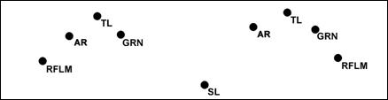
Figure 3-6. Squad line.
Squad File
3-43. The squad file has the same characteristics as the fire team file (Figure 3-7). In the event that the terrain is severely restrictive or extremely close, teams within the squad file may also be in file. This disposition is not optimal for enemy contact, but does provide the squad leader with maximum control. If the squad leader wishes to increase his control over the formation he moves forward to the first or second position. Moving forward also enables him to exert greater morale presence by leading from the front, and to be immediately available to make key decisions. Moving a team leader to the last position can provide additional control over the rear of the formation.
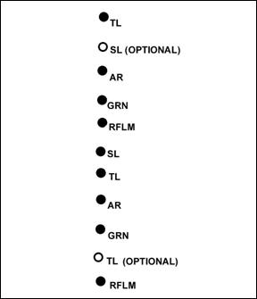
Figure 3-7. Squad file.
Weapons Squad Movement Formations
3-44. The weapons squad is not a rifle squad and should not be treated as such. During tactical movement the platoon leader has one of two options when it comes to positioning the weapons squad. The weapons squad can either travel together as a separate entity, or can be broken up and distributed throughout the formation. The advantage to keeping the weapons squad together is the ability to quickly generate a support by fire and gain fire superiority under the direction of the weapons squad leader. The disadvantage to this approach is the lack of redundancy throughout the formation. The advantage to distributing the weapons squad throughout the rifle squads is the coverage afforded to the entire formation. The disadvantage is losing the weapons squad leader as a single command and control element and the time required to reassemble the weapons squad if needed.
3-45. When the weapons squad travels dispersed, they can either be attached to squads or attached to the key leaders like the platoon leader, platoon sergeant, and weapons squad leader. There is no standard method for their employment. Rather, the platoon leader places the weapons using two criteria: ability to quickly generate fire superiority, and protection for these high value assets.
3-46. Like the rifle squad, the weapons squad, when traveling as a squad, uses either a column or line formation. Within these formations, the two sections can also be in column or line formation.
PLATOON FORMATIONS
3-47. The actual number of useful combinations of squad and fire team combat formations within the platoon combat formations is numerous, creating a significant training requirement for the unit. Add to that the requirement to modify formations with movement techniques, immediate action drills, and other techniques, and it is readily apparent that what the platoon leader needs is a couple of simple, effective strategies. These strategies should be detailed in the unit’s SOPs. For a full description of each combat formation and advantages and disadvantages refer again to Table 3-1.
Platoon Leader Responsibilities
3-48. Like the squad leader, the platoon leader exercises command and control primarily through his subordinates and moves in the formation where he can best achieve this. The squad and team leader execute the combat formations and movement techniques within their capabilities based on the platoon leader’s guidance.
3-49. The platoon leader is responsible for 360-degree security, for ensuring that each subordinate unit’s sectors of fire are mutually supporting, and for being able to rapidly transition the platoon upon contact. He adjusts the platoon’s formation as necessary while moving, primarily through the three movement techniques (see Section III). Like the squad and team, this determination is a result of the task, the nature of the threat, the closeness of terrain, and the visibility.
3-50. The platoon leader is also responsible for ensuring his squads can perform their required actions. He does this through training before combat and rehearsals during combat. Well-trained squads are able to employ combat formations, movement techniques, actions on contact, and stationary formations.
Platoon Headquarters
3-51. The platoon leader also has to decide how to disperse the platoon headquarters elements (himself, his RTO, his interpreter, the forward observer, the platoon sergeant, and the medic). These elements do not have a fixed position in the formations. Rather, they should be positioned where they can best accomplish their tasks. The platoon leader’s element should be where he conducts actions on contact, where he can supervise navigation, and where he can communicate with higher. The FO’s element should be where he can best see the battlefield and where he can communicate with the platoon leader and the battalion fire support officer (FSO). This is normally in close proximity to the platoon leader. The platoon sergeant’s element should be wherever the platoon leader is not. Because of the platoon sergeant’s experience, he should be given the freedom to assess the situation and advise the platoon leader accordingly. Typically, this means the platoon leader is more toward the front of the formation, while the platoon sergeant is more to the rear of the formation.
Base Squad
3-52. The platoon leader designates one of the squads as the base squad. He controls the platoon’s speed and direction of movement through the base squad, while the other squads and any attachments cue their movement off of the base squad.
Moving As Part of a Larger Unit
3-53. Infantry platoons often move as part of a larger unit’s movement. The next higher commander assigns the platoon a position within the formation. The platoon leader assigns his subordinates an appropriate formation based on the situation and uses the appropriate movement technique. Regardless of the platoon’s position within the formation, it must be ready to make contact or to support the other elements by movement, by fire, or by both.
3-54. When moving in a company formation, the company commander normally designates a base platoon to facilitate control. The other platoons cue their speed and direction on the base platoon. This permits quick changes and lets the commander control the movement of the entire company by controlling only the base platoon. The company commander normally locates himself within the formation where he can best see and direct the movement of the base platoon. The base platoon’s center squad is usually its base squad. When the platoon is not acting as the base platoon, its base squad is its flank squad nearest the base platoon.
Primary Formations
3-55. Platoon formations include the column, the line (squads on line or in column), the vee, the wedge, and the file. The leader should weigh these carefully to select the best formation based on his mission and on METT-TC analysis. A comparison of the formations is in Table 3-4.
3-56. Within these platoon formations, the rifle squads are either in a column or a line. Within the rifle squad formations, the teams are in one of the six formations. Normally the platoon leader does not personally direct fire team formations, but he can do so if the situation dictates. He should at a minimum know the formation of the base fire team of the base squad. The weapons squad travels separately or attached to the rifle squads.
Table 3-4. Comparison of platoon formations.
Movement Formation |  | When Most  Often Used | CHARACTERISTICS
 |  |  | Control | Flexibility | Fire Capability/  Restrictions | Security | Movement
Platoon column |  | Platoon primary movement formation | Good for maneuver (fire and movement) | Provides good dispersion laterally and in depth | Allows limited firepower to the front and rear, but high volume to the flanks | Extremely limited overall security | Good
Platoon line, squads on line |  | When the leader wants all Soldiers forward for maximum firepower to the front and the enemy situation is known | Difficult | Minimal | Allows maximum firepower to the front, little to flanks and rear | Less secure than other formations because of the lack of depth, but provides excellent security for the higher formation in the direction of the echelon | Slow
Platoon line, squads in column |  | May be used when the leader does not want everyone on line; but wants to be prepared for contact; when crossing the LD when LD is near the objective | Easier than platoon line, squads on line, but more difficult than platoon column | Greater than platoon column, squads on line, but less than platoon line, squads on line | Good firepower to the front and rear, minimum fires to the flanks; not as good as platoon column, better than platoon line | Good security all around | Slower than platoon column, faster than platoon line, squads on line
Platoon vee | When the enemy situation is vague, but contact is expected from the front |  | Difficult | Provides two squads up front for immediate firepower and one squad to the rear for movement (fire and movement) upon contact from the flank | Immediate heavy volume of firepower to the front or flanks, but minimum fires to the rear | Good security to the front | Slow
Platoon wedge | When the enemy situation is vague, but contact is not expected |  | Difficult but better than platoon vee and platoon line, squads on line | Enables leader to make contact with a small element and still have two squads to maneuver | Provides heavy volume of firepower to the front or flanks | Good security to the flanks | Slow, but faster than platoon vee
Platoon file | When visibility is poor due to terrain, vegetation, or light |  | Easiest | Most difficult formation from which to maneuver | Allows immediate fires to the flanks, masks most fires to front and rear | Extremely limited overall security | Fastest for dismounted movement
Platoon Column
3-57. In the platoon column formation, the lead squad is the base squad (Figure 3-8). It is normally used for traveling only.

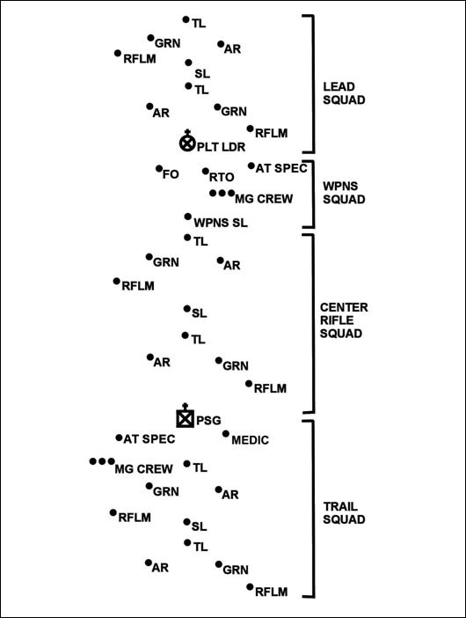
Figure 3-8. Platoon column.
NOTE: METT-TC considerations determine where the weapons squad or machine gun teams locate in the formation. They normally move with the platoon leader and /or PSG so he can establish a base of fire quickly.
Platoon Line, Squads on Line
3-58. In the platoon line, squads on line formation, when two or more platoons are attacking, the company commander chooses one of them as the base platoon. The base platoon’s center squad is its base squad. When the platoon is not acting as the base platoon, its base squad is its flank squad nearest the base platoon. The weapons squad may move with the platoon, or it can provide the support-by-fire position. This is the basic platoon assault formation (Figure 3-9).
3-59. The platoon line with squads on line is the most difficult formation from which to make the transition to other formations.
3-60. It may be used in the assault to maximize the firepower and shock effect of the platoon. This normally is done when there is no more intervening terrain between the unit and the enemy, when antitank systems are suppressed, or when the unit is exposed to artillery fire and must move rapidly.

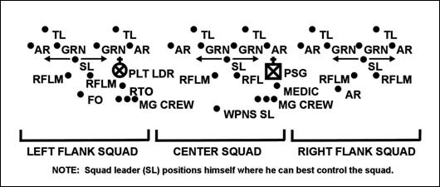
Figure 3-9. Platoon line, squads on line.
Platoon Line, Squads in Column
3-61. When two or more platoons are moving, the company commander chooses one of them as the base platoon. The base platoon’s center squad is its base squad. When the platoon is not the base platoon, its base squad is its flank squad nearest the base platoon (Figure 3-10). The platoon line with squads in column formation is difficult to transition to other formations.

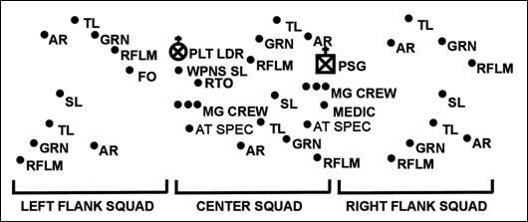
Figure 3-10. Platoon line, squads in column.
Platoon Vee
3-62. This formation has two squads up front to provide a heavy volume of fire on contact (Figure 3-11). It also has one squad in the rear that can either overwatch or trail the other squads. The platoon leader designates one of the front squads to be the platoon’s base squad.
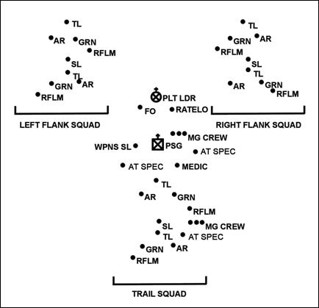
Figure 3-11. Platoon vee.
Platoon Wedge
3-63. This formation has two squads in the rear that can overwatch or trail the lead squad (Figure 3-12). The lead squad is the base squad. The wedge formation—
– Can be used with the traveling and traveling overwatch techniques.
– Allows rapid transition to bounding overwatch.

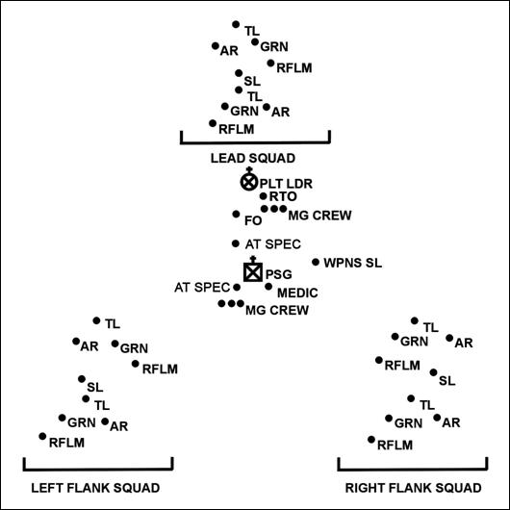
Figure 3-12. Platoon wedge.
Platoon File
3-64. This formation may be set up in several methods (Figure 3-13). One method is to have three-squad files follow one another using one of the movement techniques. Another method is to have a single platoon file with a front security element (point) and flank security elements. The distance between Soldiers is less than normal to allow communication by passing messages up and down the file. The platoon file has the same characteristics as the fire team and squad files. It is normally used for traveling only.

